
Data Collection Worksheet
Please Note: The Data Collection Worksheet (DCW) is a tool to aid integration of a PhenX protocol into a study. The PhenX DCW is not designed to be a data collection instrument. Investigators will need to decide the best way to collect data for the PhenX protocol in their study. Variables captured in the DCW, along with variable names and unique PhenX variable identifiers, are included in the PhenX Data Dictionary (DD) files. Buttocks (Hip) Circumference
The SP (study participant) stands erect with feet together and weight evenly distributed on both feet. The SP is holding up the examination gown. The recorder stands in back of the SP and gathers the side seams of the exam pants together above the hips and places the thumb in the fabric to make a fold. The recorder holds the folded sides of the pants snugly while the examiner squats on the right side of the SP and places the measuring tape around the buttocks. The tape is placed at the maximum extension of the buttocks (see Exhibit 1). The recorder then adjusts the sides of the tape and checks the front and sides so that the plane of the tape is horizontal. The zero end of the tape is held under the measurement value. The tape is held snug but not tight. The examiner takes the measurement from the right side and calls it to the recorder.
Figure 1.
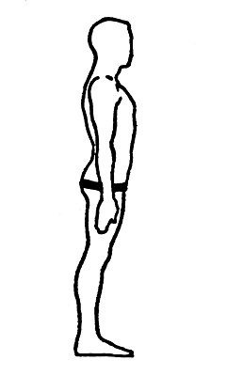
Protocol source: https://www.phenxtoolkit.org/protocols/view/20802

