PROTOCOL 750304
SHOW GENERIC IMAGE OF E-PRODUCTS | 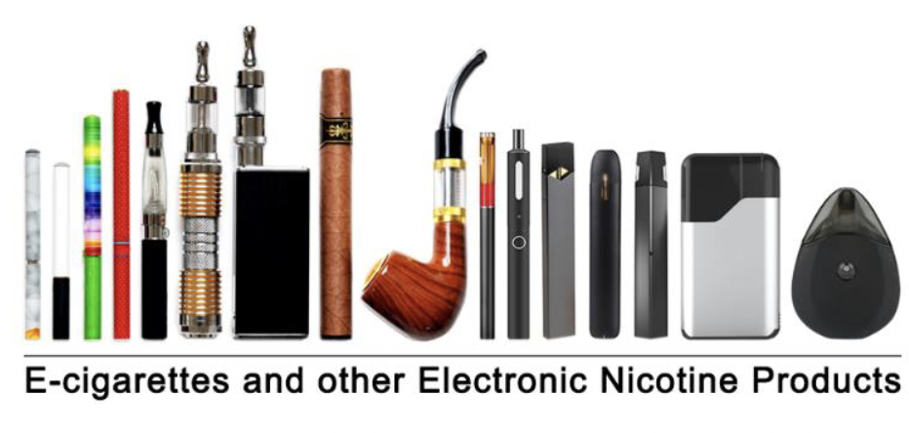
SHOW GENERIC IMAGE OF TRADITIONAL CIGARS
SHOW GENERIC IMAGE OF CIGARILLOS AND FILTERED CIGARS
SHOW GENERIC IMAGE OF PIPE AND PIPE TOBACCO | 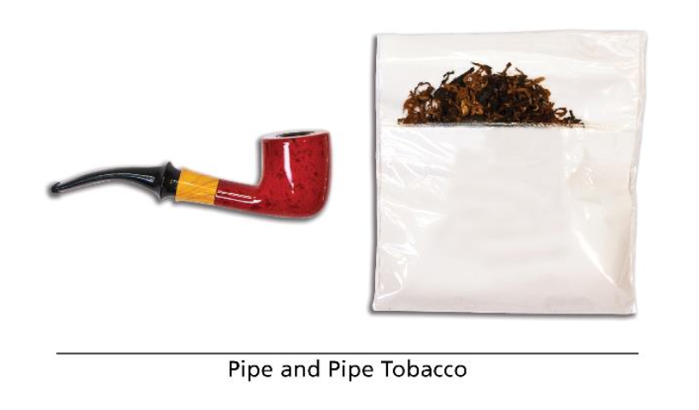
SHOW GENERIC IMAGE OF HOOKAH AND SHISHA | 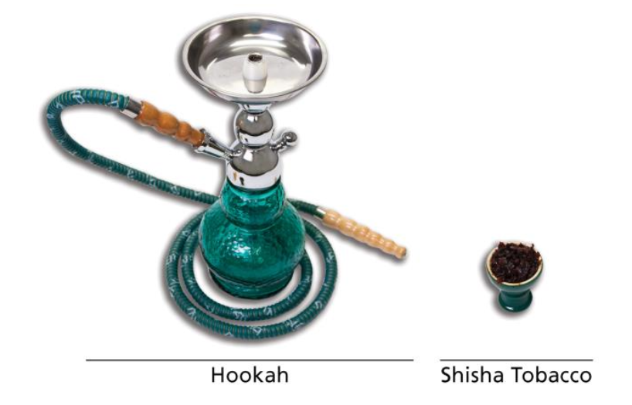
SHOW GENERIC IMAGE OF SMOKELESS PRODUCTS, EXCLUDING SNUS | 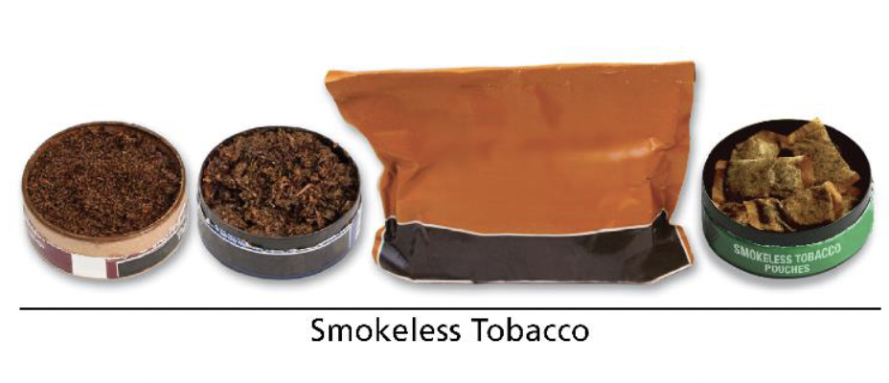
SHOW GENERIC IMAGE OF SNUS | 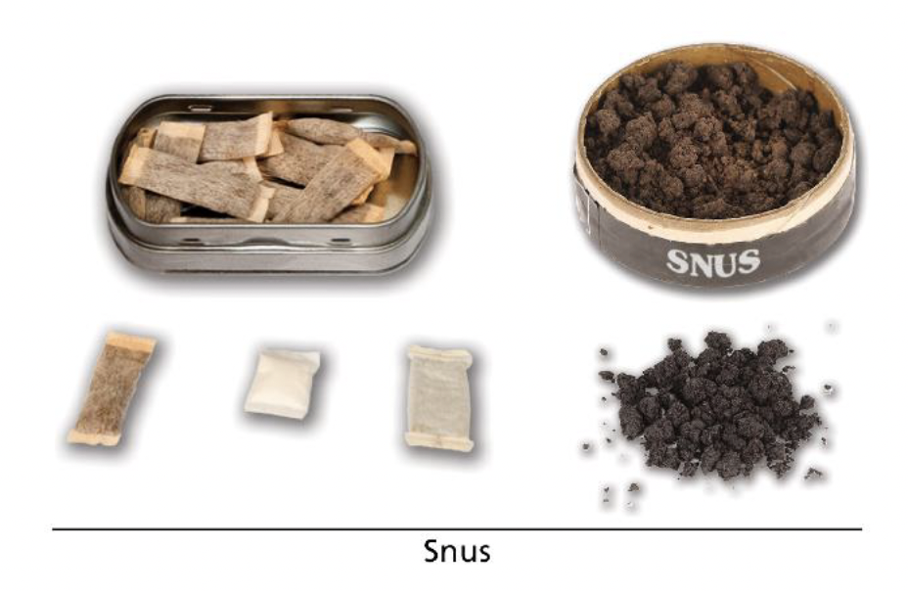
SHOW GENERIC IMAGE OF IQOS | 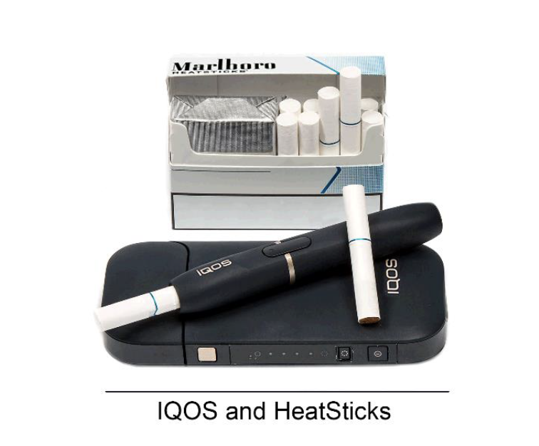
SHOW GENERIC IMAGE OF NICOTINE POUCHES | 